ML Network Intrusion Detector
Project Report
A Streamlit-based machine learning dashboard for classifying network traffic as normal or one of four attack types

IBM SkillsBuild Cyber Security 2026
Conducted by BharatCares

Submitted by: Rajashree C
BCA Data Science

1. Abstract
This project presents an ML Network Intrusion Detector, a machine-learning powered Network Intrusion Detection System (NIDS) built with Python, Scikit-learn and Streamlit. The system classifies a network connection as normal or as one of four attack categories: Denial of Service (DoS), Probe, Remote-to-Local (R2L) and User-to-Root (U2R). Three supervised classifiers (Random Forest, Decision Tree and Logistic Regression) are trained on a synthetic dataset of 5,000 records that mirrors the structure of the NSL-KDD benchmark, and are compared using accuracy, precision, recall, F1-score and confusion matrices. Results are presented through an interactive dark-themed dashboard with live traffic classification. On the held-out test set, Random Forest and Logistic Regression both reached 100% accuracy and Decision Tree reached 99.68%. Because the data is synthetic and the classes are cleanly separated, these scores demonstrate the working pipeline rather than real-world performance.

2. Introduction
Organisations rely on networked services that are constantly exposed to attacks such as flooding, port scanning, password guessing and privilege escalation. Traditional intrusion detection systems depend on hand-written signatures, which only recognise known attack patterns and need constant updating. Machine-learning based detection learns patterns from labelled traffic and can generalise to variations of known attacks, making it a useful complementary layer of defence.
This project demonstrates that idea end to end: generating data, training and comparing models, evaluating them, and exposing the best model through a simple web interface that anyone can use without writing code.

3. Problem Statement
Given a record describing a single network connection (duration, bytes transferred, protocol, service, connection flag, error rates and host statistics), predict whether the connection is normal or belongs to one of four attack classes, and report the model's confidence.

4. Objectives
- Create a self-contained, NSL-KDD-style dataset that needs no external download.
- Train and compare three Scikit-learn classifiers for multi-class attack detection.
- Evaluate models with accuracy, precision, recall, F1-score, confusion matrix and feature importance.
- Build an interactive Streamlit dashboard for data exploration, live detection and model performance review.
- Document the limitations of using synthetic data and outline future improvements.

5. Dataset

5.1 Source and Approach
The dataset is inspired by NSL-KDD, the improved version of the KDD Cup 99 intrusion dataset published by the Canadian Institute for Cybersecurity at the University of New Brunswick (https://www.unb.ca/cic/datasets/nsl.html). Instead of downloading the real files, the application generates 5,000 synthetic records at runtime using a fixed random seed (42), so results are reproducible. Each attack class is generated from its own value ranges; for example, DoS records have very high connection counts and SYN error rates, while Probe records have high different-service rates.

5.2 Class Distribution
Class | Proportion | Records
Normal | 45% | 2250
DoS | 35% | 1750
Probe | 12% | 600
R2L | 5% | 250
U2R | 3% | 150

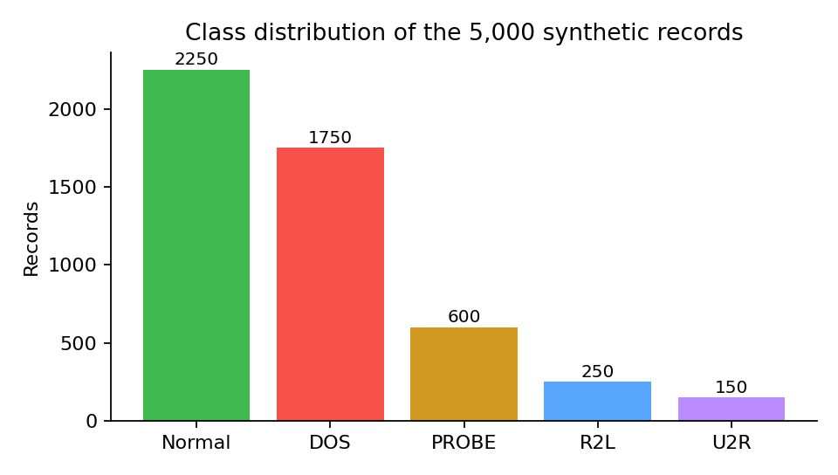
Figure 1: Class distribution of the synthetic dataset

5.3 Attack Classes
Class | Description
Normal | Legitimate network traffic
DoS | Denial of Service: flood attacks that disrupt services
Probe | Port scanning and reconnaissance
R2L | Remote-to-Local: unauthorised remote access attempts
U2R | User-to-Root: privilege escalation attempts

5.4 Features
Each record has 21 input features: duration, src_bytes, dst_bytes, land, wrong_fragment, urgent, hot, num_failed_logins, logged_in, count, srv_count, serror_rate, rerror_rate, same_srv_rate, diff_srv_rate, dst_host_count, dst_host_srv_count and dst_host_serror_rate (18 numeric), plus the categorical features protocol_type, service and flag. The target is the attack label.

6. Technologies Used
Component | Technology
Language | Python 3.9+
Web framework | Streamlit 1.35 or later
Machine learning | Scikit-learn 1.4 or later
Data handling | Pandas 2.1 or later, NumPy 1.26 or later
Visualisation | Matplotlib 3.8 or later

7. System Design and Methodology

7.1 Workflow
The application follows a simple pipeline: generate synthetic data, encode categorical features, split into training and test sets, train three models, evaluate them, and serve the best model through the dashboard. Data generation and model training are cached by Streamlit so they run only once per session.

7.2 Preprocessing
- Categorical features (protocol_type, service, flag) and the class label are converted to integers with LabelEncoder.
- The data is split 75% training and 25% testing (1,250 test records) using a stratified split so every class keeps its proportion.
- For Logistic Regression, a StandardScaler is placed inside a Scikit-learn Pipeline so scaling is learned from the training data only.

7.3 Models
Model | Configuration and rationale
Random Forest | 100 trees; robust, handles mixed features and provides feature importances
Decision Tree | Maximum depth 12; fast and easy to interpret
Logistic Regression | Up to 500 iterations with feature scaling; linear baseline

7.4 Evaluation Metrics
Models are evaluated on the held-out test set using accuracy, weighted precision, weighted recall and weighted F1-score, together with a confusion matrix and per-class classification report. Weighted averages account for the class imbalance, and the per-class report is important because R2L and U2R are rare.

7.5 Dashboard Pages
Page | Purpose
Dashboard | Traffic distribution charts, attack breakdown, best-model metrics and sample records
Detect Traffic | Form with 21 connection features that returns a predicted class and confidence score
Model Performance | Model comparison table, confusion matrix, classification report and feature importance
About | Background on NIDS, dataset details, limitations and future work

8. Implementation
The whole application is contained in a single file, app.py, supported by requirements.txt and README.md. Key functions are:
- generate_synthetic_data(): creates the 5,000-record dataset with class-specific value ranges.
- train_models(): encodes features, splits the data, trains the three pipelines and returns metrics, confusion matrices and reports.
- dark_fig(): applies a consistent dark theme to Matplotlib charts.
- Page logic: a sidebar radio selector switches between the four pages. The best model is chosen by highest accuracy and is used for live predictions.
To run the project: install dependencies with pip install -r requirements.txt and start the app with streamlit run app.py. It opens in the browser at http://localhost:8501.

9. Results
All results below were obtained on the 1,250-record held-out test set.

9.1 Model Comparison
Model | Accuracy | Precision | Recall | F1-Score
Random Forest | 100.00% | 100.00% | 100.00% | 100.00%
Decision Tree | 99.68% | 99.68% | 99.68% | 99.68%
Logistic Regression | 100.00% | 100.00% | 100.00% | 100.00%

Random Forest and Logistic Regression classified every test record correctly. Decision Tree reached 99.68% accuracy, making four errors out of 1,250: one R2L record predicted as U2R and three U2R records predicted as R2L.

9.2 Confusion Matrices
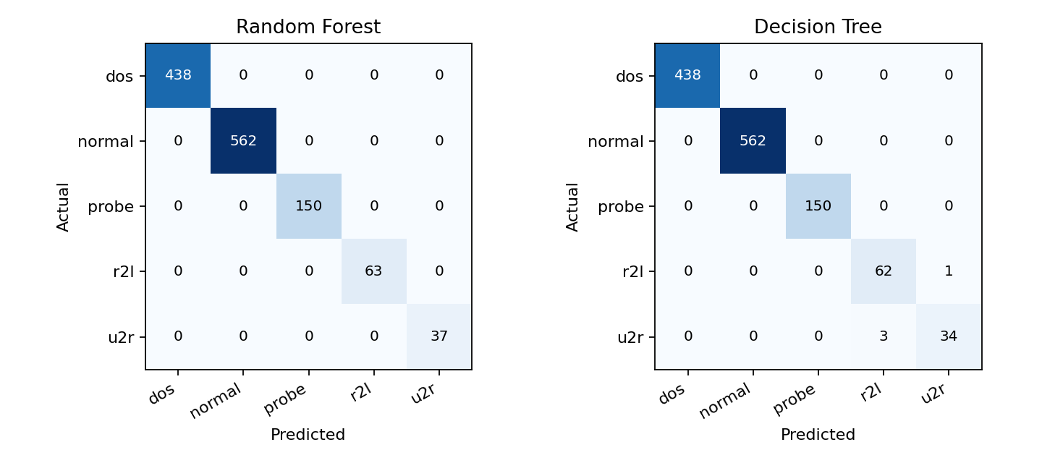
Figure 2: Confusion matrices for Random Forest and Decision Tree

9.3 Per-class Results (Decision Tree)
Class | Precision | Recall | F1-Score | Support
dos | 1.00 | 1.00 | 1.00 | 438
normal | 1.00 | 1.00 | 1.00 | 562
probe | 1.00 | 1.00 | 1.00 | 150
r2l | 0.95 | 0.98 | 0.97 | 63
u2r | 0.97 | 0.92 | 0.94 | 37

9.4 Feature Importance
The Random Forest ranks dst_host_serror_rate, dst_bytes, logged_in, srv_count and diff_srv_rate as the most influential features. These match the way the synthetic classes were designed: SYN error rates and connection counts separate DoS traffic, while the different-service rate separates Probe traffic.
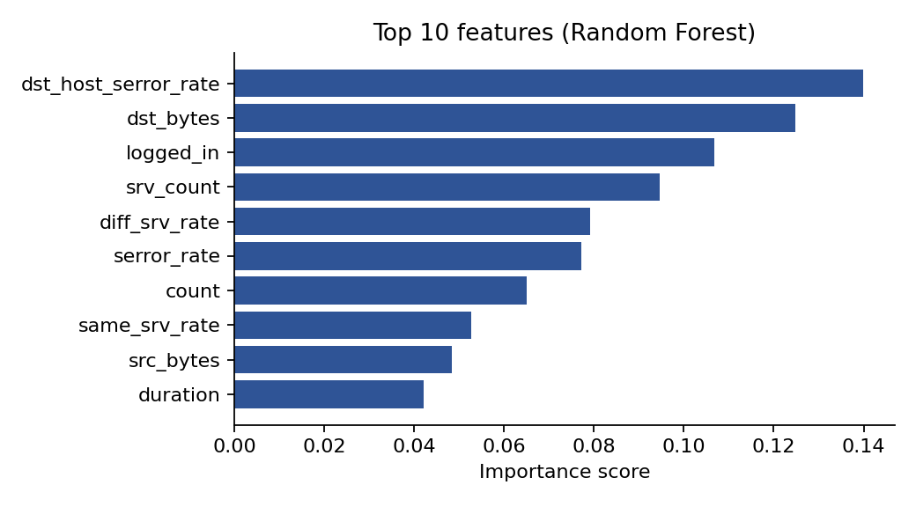
Figure 3: Top 10 feature importances from the Random Forest

9.5 Discussion
The near-perfect scores should be read with care. The synthetic classes are generated from clearly separated value ranges, so even a simple linear model can separate them. The only errors appear between R2L and U2R, the two rarest and most similar classes, and only for the Decision Tree. On real network traffic, where attack and normal behaviour overlap, scores would be lower and the differences between models would be larger. The project therefore validates the pipeline and the dashboard rather than claiming real-world detection accuracy.

10. Limitations
- Synthetic data only: the records do not represent real network captures.
- No live packet capture or network interface access.
- NSL-KDD patterns are based on 1999 traffic, and modern attacks differ significantly.
- Class imbalance: R2L and U2R are rare, so accuracy alone can be misleading.
- Not suitable for production deployment or real security decisions.

11. Future Enhancements
- Train and test on the real NSL-KDD or CIC-IDS2017 dataset.
- Add CSV batch upload for bulk predictions.
- Log prediction history in SQLite.
- Add SHAP explainability charts.
- Deploy to Streamlit Community Cloud.
- Explore LSTM or autoencoder models for anomaly-based detection.

12. Conclusion
The ML Network Intrusion Detector shows how supervised machine learning can be applied to network security from data generation to an interactive user interface. Three classifiers were trained and compared, with Random Forest and Logistic Regression achieving perfect test accuracy and Decision Tree 99.68% on the synthetic dataset. The dashboard makes the results easy to explore and lets a user classify a connection and see a confidence score. With real datasets and further tuning, the same structure can be extended into a more realistic intrusion detection prototype.

13. References
- Tavallaee, M., Bagheri, E., Lu, W., Ghorbani, A. A. (2009). A Detailed Analysis of the KDD CUP 99 Data Set. IEEE Symposium on Computational Intelligence for Security and Defense Applications.
- NSL-KDD dataset, Canadian Institute for Cybersecurity, University of New Brunswick: https://www.unb.ca/cic/datasets/nsl.html
- Scikit-learn documentation: https://scikit-learn.org
- Streamlit documentation: https://docs.streamlit.io

